XGBoost Regressor - Detailed Learning Handbook

Definition
XGBoost Regressor is a boosting algorithm that builds trees sequentially. Each new tree learns from previous prediction errors (residuals).

Category
Machine Learning > Supervised Learning > Regression

Use Cases
House Price Prediction
Demand Forecasting
Sales Prediction
Risk Scoring

Core Concept
Boosting

Sample Dataset
Feature X | Target Y
1 | 10
2 | 12
3 | 25
4 | 28
5 | 40
6 | 45

Residual Calculation Table
Actual | Prediction | Residual
100 | 80 | 20
120 | 110 | 10
130 | 120 | 10

Graph Visualization
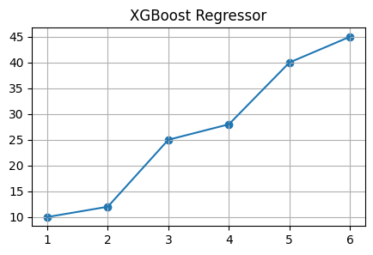

Python Implementation
from xgboost import XGBRegressor
X=[[1],[2],[3],[4],[5],[6]]
y=[10,12,25,28,40,45]
model=XGBRegressor(n_estimators=100,max_depth=3,learning_rate=0.1)
model.fit(X,y)
prediction=model.predict([[3.5]])
print(prediction)

Important Hyperparameters
n_estimators
max_depth
learning_rate
subsample
colsample_bytree

Advantages
High accuracy
Handles non-linear data
Works with large datasets

Limitations
More computationally expensive than Linear Regression

Interview Questions
What is it?
Why use it?
Difference from Decision Tree?
Important hyperparameters?
Real-world use cases?

